|  |  |  |  |  |  |
| --- | --- | --- | --- | --- | --- |
| Date | 24-Nov-22 | | | Tester Name | Mayuri Patel |
| Environment | Penfax - Test | | | Login used |  |
| Operating System | Select OS | Version: | Update: | | |
| Software Used | Select Software | Version: | Update: | | |
| Select Software | Version: | Update: | | |
| Release version | 22.4.1 | | | | |
| Title |  | | | | |
| Test Type | Regression | | | | |
| Test Scenario | Change surname on existing beneficiary | | | | |
|  |  | | | | |
| Expected Results |  | | | | |
| Pass/Fail | Pass | | | JIRA# | N/A |

Describe your steps with screenshots:

Search for any MEPP member that have beneficiary listed (SID-128573 selected)

Open that member profile in Penfax (SID-128573 Opened)

Under person profile, beneficiary tab🡪beneficiary Designations

Open beneficiary profile SID-442614 by clicking on stakeholder ID of Beneficiary

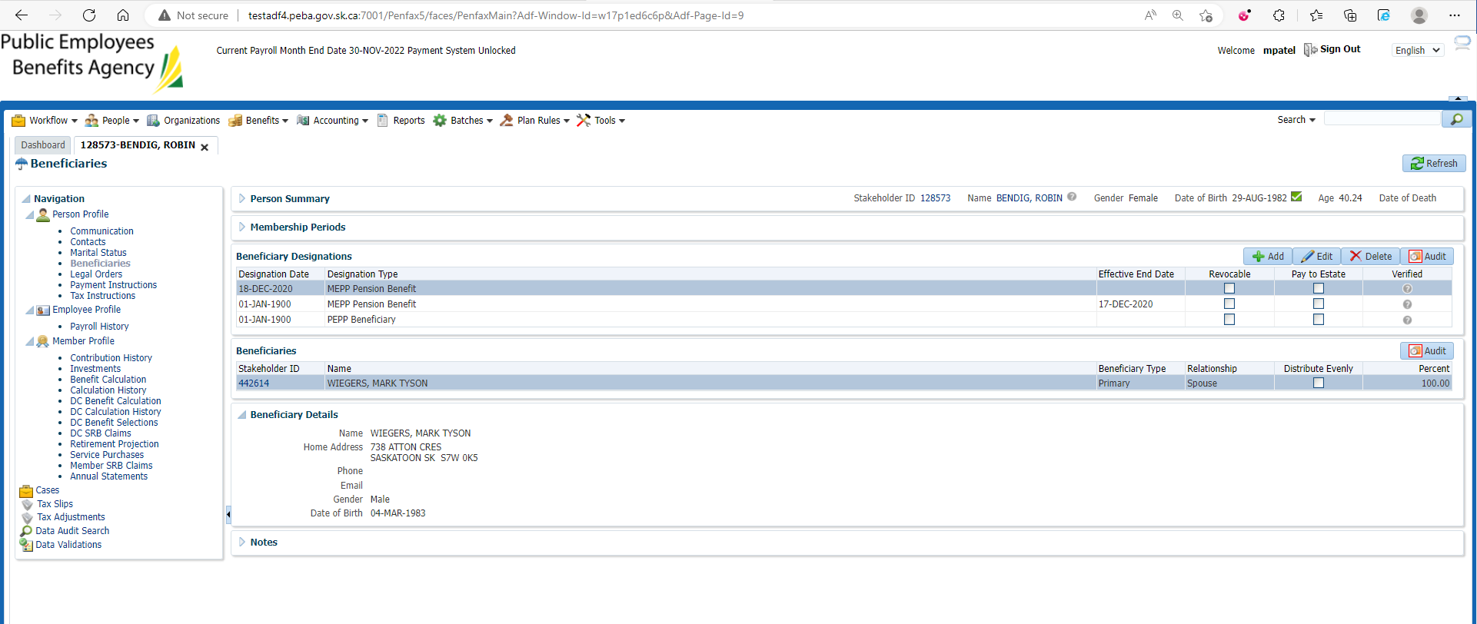

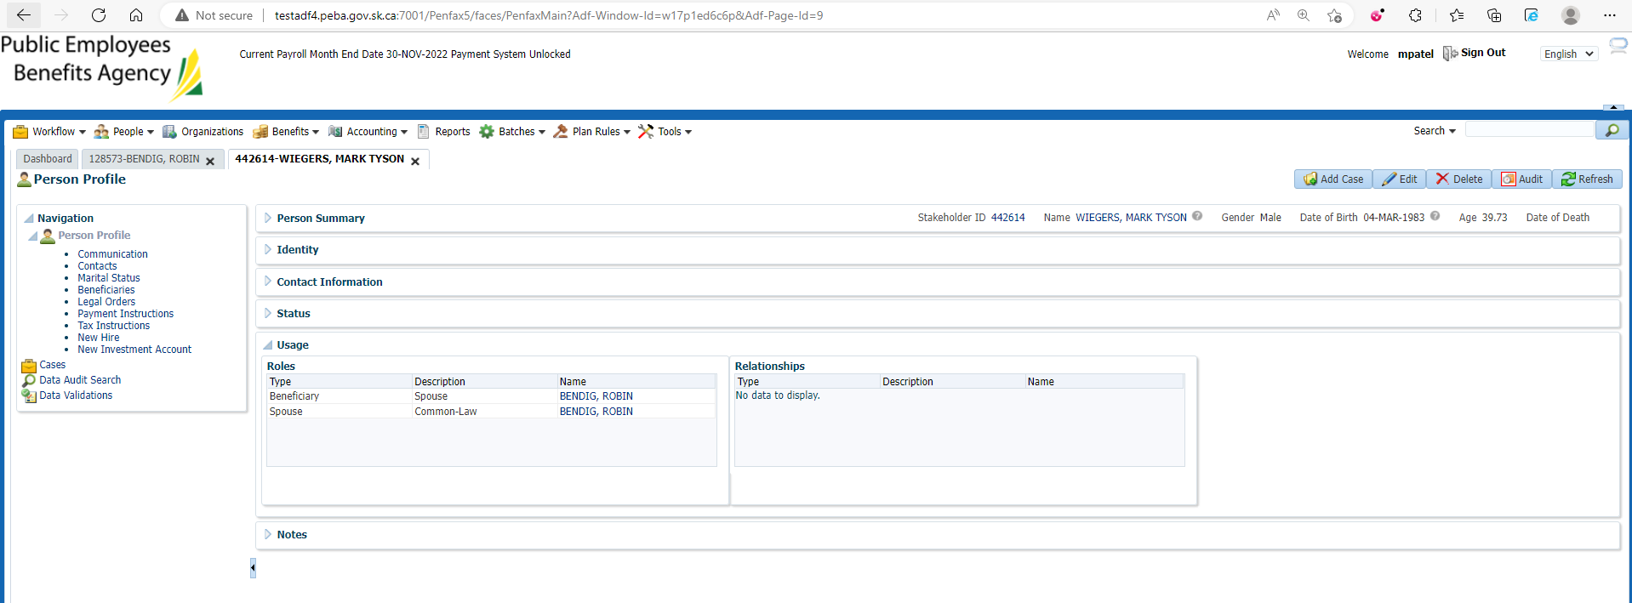

Under Person profile🡪Identity

Edit Identity

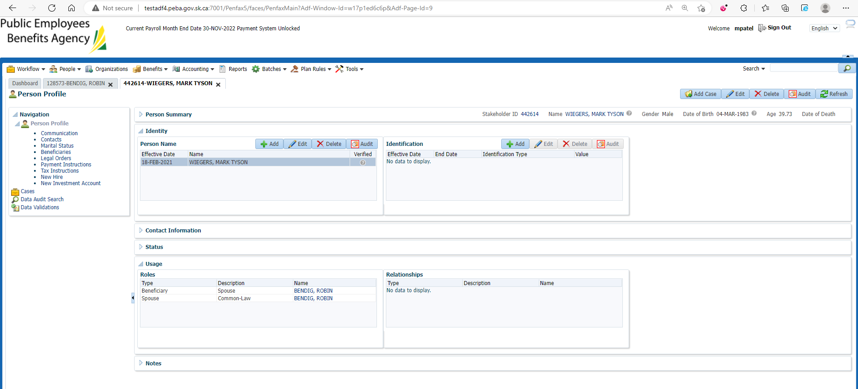

Change Last name and save the details

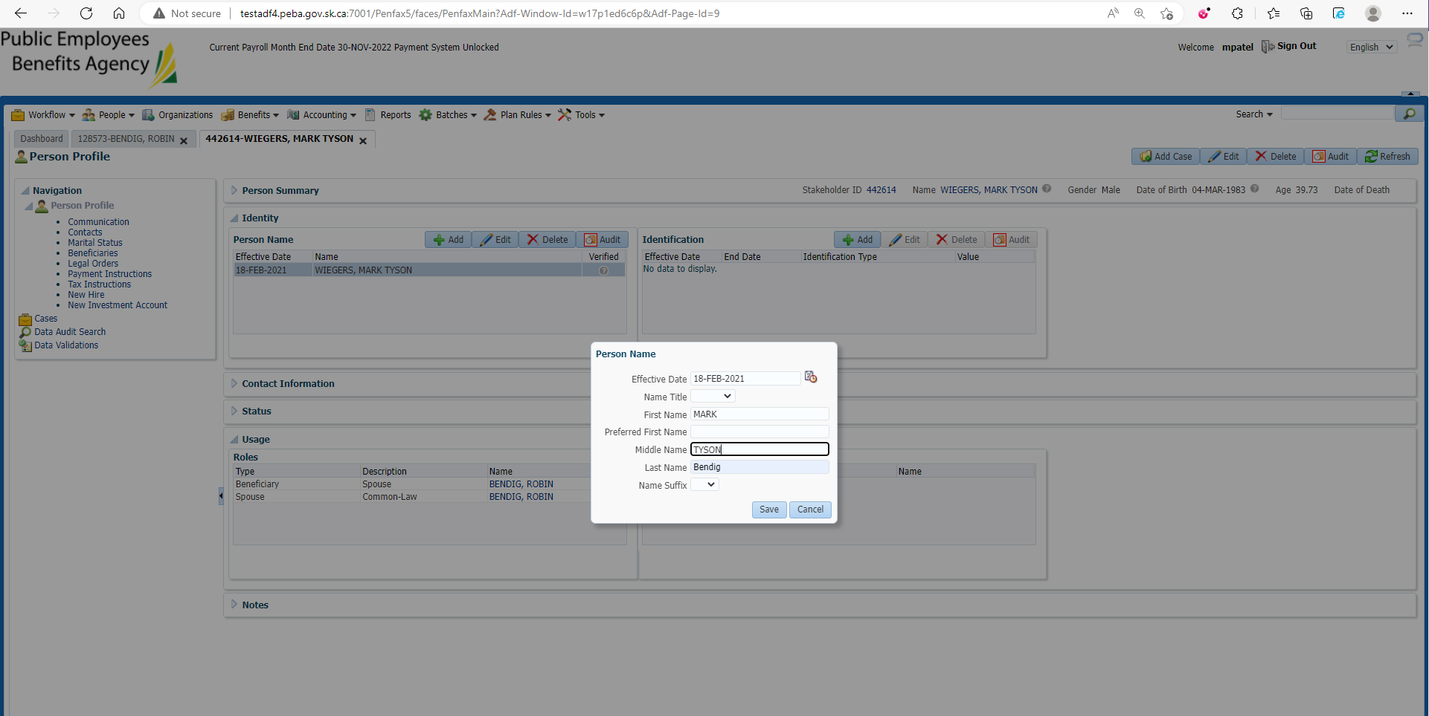

Changes are reflected on SID-442614

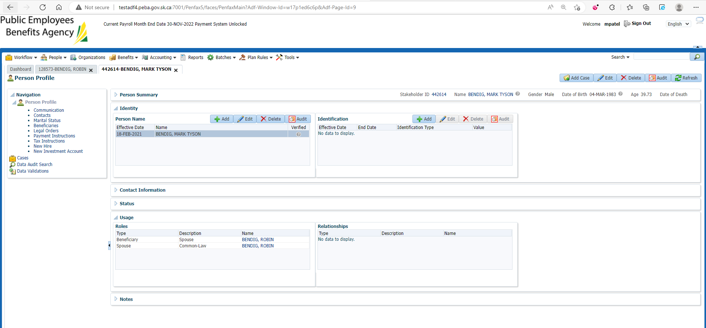

Same changes are reflected on SID-128573

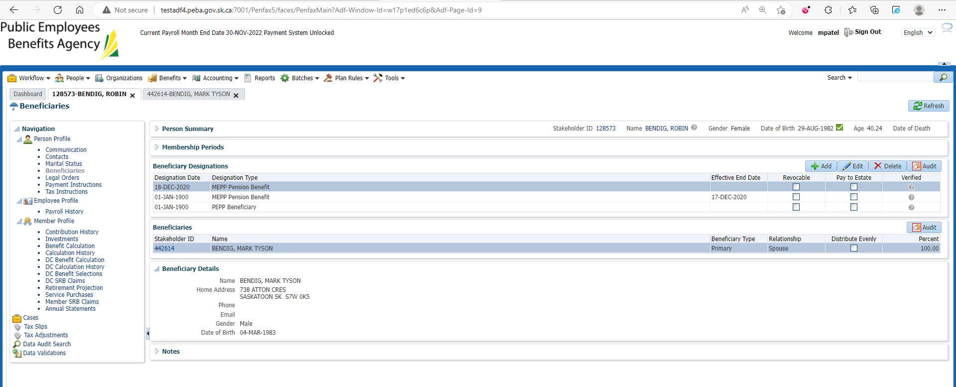

Changes are reflected in Pen web

